**What are private networks and public networks**

* Private Network:
  + This is network of systems which is not accessible externally (over internet)
  + can be connected to internet
  + there are reserved ip ranges for private network
    - 192.168.0.0 to 192.168.255.255
    - 10.0.0.0 to 10.255.255.255
    - 172.16.0.0 to 172.31.255.255
* Public Network:
  + This is network of systems which is accessible externally (over internet)
  + it is connected to internet
  + other ips than defined above
* In cloud we always create private networks

**How internet works for private networks**

* Home network  
  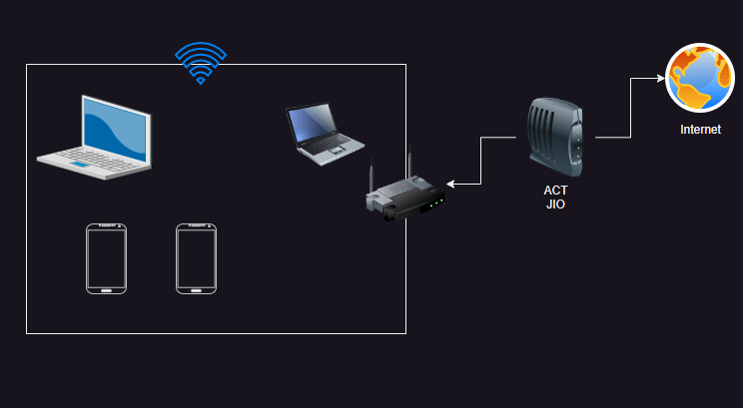

**Network principles**

* All the devices in the same network can communicate with each other over unique ip address
* When systems communicate there are networking protocols which will enable the communication  
  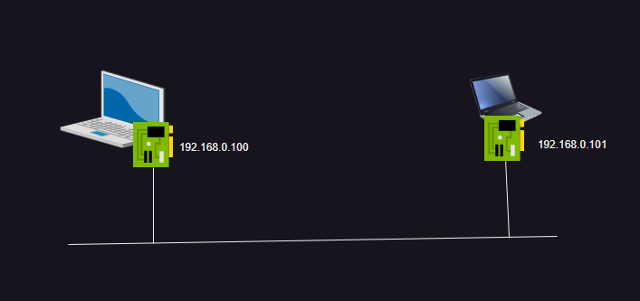
* We have two models
  + [OSI](https://www.geeksforgeeks.org/open-systems-interconnection-model-osi/) : This is theoritical model and is used as reference
  + TCP/IP  
    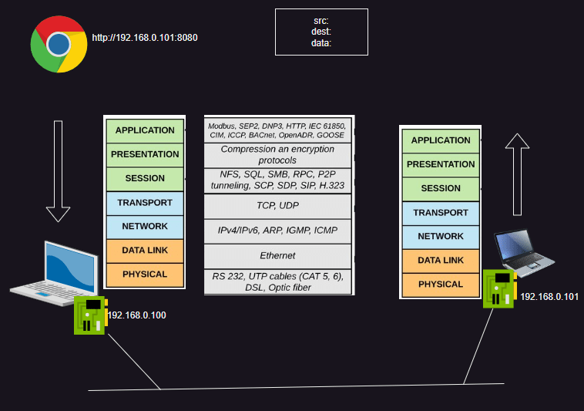
* Router is a device which can forward network packets from one network to another. Every Router will have rules which are generally referred as route tables
* DNS (Domain Naming System) is responsible for resolving names
* Concepts:
  + Routing
  + DNS
  + SSL/TLS (https)

**Networking contd**

* Any device connected to a network will get an ip address which is a unique id to access that device
* An Ipaddress can be public or private
* public ip (unique globally)
* private ip (unique within network)
* Our discussion will be on private network so private ip’s primarily
* IP Address = network id + host id  
  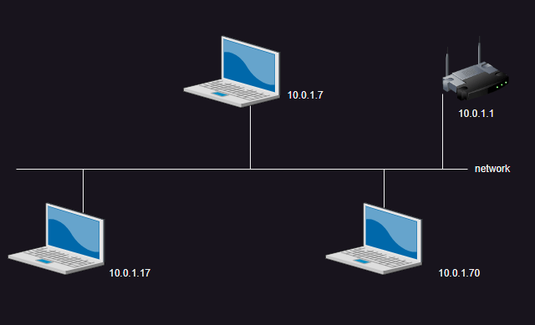
* IP Address are of two formats
  + IPv4:
    - ip address is a 32 bit number which is divided into 4 parts (octet) x.x.x.x
    - each octet will have 256 numbers ranging from 0 to 255
    - ipv4 range is 0.0.0.0 to 255.255.255.255
  + IPv6:
    - ip address is 128 bit number  
      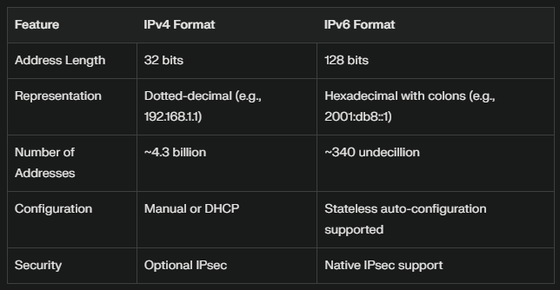
* To determine what is network id and what is host id we need subnet masks
* Examples

## 1

ip: 10.0.1.7

sm: 255.255.255.0

nid: 10.0.1

hid: 7

## 2

ip: 10.0.1.7

sm: 255.255.0.0

nid: 10.0

hid: 1.7

* network id is constant for every device in the network and host id is variable, this determines the size of network.
* size of network = 2 ^ (n) – 2
  + n = number of host id bits
* we subtract from 2 because
  + all zeros is network id
  + all ones (255) is broadcast id
* Examples

## 1

ip: 10.0.1.7

sm: 255.255.255.0

nid: 10.0.1

hid: 7

hid size = 1 octect = 8 bits

size = 2^8 - 2 = 256 - 2 = 254

## 2

ip: 10.0.1.7

sm: 255.255.0.0

nid: 10.0

hid: 1.7

hid size = 2 octets = 16 bits

size = 2^16-2 = 65536 - 2 = 65534

## 3

ip: 10.0.1.7

sm: 255.0.0.0

nid: 10

hid: 0.1.7

hid size = 3 octects = 24 bits

size = 2^24 -2 = 16777216 - 2 = 16777214

* I want a network to connect 500 devices

size = 500

2 ^n - 2 ~ = 500

valid values of n = 8, 16, 24

in this case lets go with 16

n = 16 = 2 octects for host id

sm = 255.255.0.0

* CIDR (Classless Interdomain routing was introduced). All clouds use CIDR to define network ranges

**CIDR**

* look at ip address as bits not octets
* lets go with the example

ip: 10.0.1.7

SM: 255.255.255.0 (older)

SM: 11111111.11111111.11111111.00000000

* hostid : will have sequence of 1’s in SM
* network id: will have sequence of zeros
* I want a network with 500 devices

2 ^ n - 2 = 500

valid values of n are any where between 2 to 31

2^n ~= 500

n = 9

hid bits = 9

nid bits = 32 - 9 = 23

SM: 11111111.11111111.11111110.00000000

255.255.254.0

* I want a network with 100 devices what is SM

2^n - 2 ~ = 100

2^n ~= 100

n = 7

hid bits = 7

nid bits = 32 - 7 = 25

SM: 11111111.11111111.11111111.10000000

255.255.255.128

* I want a network of size 2000 devices find the subnet mask

2 ^ n -2 ~= 2000

n = 11

hid bits = 11

nid bits = 32 - 11 = 21

SM: 11111111.11111111.11111000.00000000

255.255.248.0

* CIDR is represented as x.x.x.x/N
  + N = number of network id bits
* Expand CIDR 10.0.0.0/24:

ip: 10.0.0.xxxxxxxx

ip: 10.0.0.00000000 = 10.0.0.0

ip: 10.0.0.11111111 = 10.0.0.255

SM: 11111111.11111111.11111111.00000000

range: 10.0.0.0 to 10.0.0.255

* Expand CIDR: 10.0.0.0/8

ip: 10.xxxxxxxx.xxxxxxxx.xxxxxxxx

ip: 10.00000000.00000000.00000000 = 10.0.0.0

ip: 10.11111111.11111111.11111111 = 10.255.255.255

SM: 11111111.00000000.00000000.00000000

* Expand CIDR: 172.16.0.0/12

ip 172.0001xxxx.xxxxxxxx.xxxxxxxx

ip: 172.00010000.00000000.00000000 = 172.16.0.0

ip 172.00011111.11111111.11111111 = 172.31.255.255

SM: 11111111.11110000.00000000.00000000

* Expand CIDR: 192.168.128.0/18

ip: 192.168.10xxxxxx.xxxxxxxx

ip: 192.168.10000000.00000000 = 192.168.128.0

ip: 192.168.10111111.11111111 = 192.168.191.255

SM: 11111111.11111111.11000000.00000000

**Private networks**

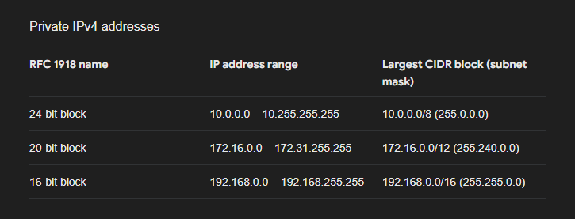

* Choosing a private cidr range has two criteria
  + choose a cidr which fits your size
  + choose a cidr different than any other private network which it needs to comunicate with in such a way that ips donot collide with each other

**Subnetting**

* subnet (sub-network)
* This is dividing networks into smaller networks

**Problem 1**

* I want to create a network of 500 devices and create two subnets with the capacity of 250 each
* note:
  + n: hostid bits
  + N: network id bits
* Network

2^n -2 ~= 500

n = 9

N = 32 - 9 = 23

192.168.0.0/23

* subnets = 2

2^n - 2 ~= 250

n = 8

N = 32 - 8 = 24

network ip: 192.168.0.0/23

network sm: 11111111.11111111.11111110.00000000

subnet sm: 11111111.11111111.11111111.00000000

-------------------------------------------------

X

subnet 1 : 192.168.00000000.xxxxxxxx => 192.168.0.0/24

subnet 2 : 192.168.00000001.xxxxxxxx => 192.168.1.0/24

**Problem 2:**

* I want a network of 1000 devices with two subnets of 500 each
* Network

2^n ~= 1000

n = 10

N = 32 - 10 = 22

172.16.0.0/22

* Subnet = 2

2 ^ n ~= 500

n = 9

N = 32 - 9 = 23

network ip: 172.16.0.0/22

network SM: 11111111.11111111.11111100.00000000

subnet SM : 11111111.11111111.11111110.00000000

--------------------------------------------------

X

subnet 1 : 172.16.0000000x.xxxxxxxx => 172.16.0.0/23

subnet 2 : 172.16.0000001x.xxxxxxxx => 172.16.2.0/23

**Problem 3**

* I need a network for 4 subnets with 100 devices each
* Network:

2^n ~= 400

n = 9

N = 32 -9 = 23

network ip: 10.0.0.0/23

* subnet

2^n ~= 100

n = 7

N = 32-7 = 25

network ip: 10.0.0.0/23

network SM: 11111111.11111111.11111110.00000000

subnet SM : 11111111.11111111.11111111.10000000

-------------------------------------------------

X.X

subnet 1: 10.0.00000000.0xxxxxxx => 10.0.0.0/25

subnet 2: 10.0.00000000.1xxxxxxx => 10.0.0.128/25

subnet 3: 10.0.00000001.0xxxxxxx => 10.0.1.0/25

subnet 4: 10.0.00000001.1xxxxxxx => 10.0.1.128/25

**Problem 4**

* Create 2 subnets of size 50000 devices
* Network size = 100000

2^n ~= 100000

n = 17

N = 32 -17 = 15

network ip: 10.0.0.0/15

* subnets

2^n ~= 50000

n = 16

N = 32 - 16 = 16

network ip: 10.0.0.0/15

network SM: 11111111.11111110.00000000.00000000

subnet SM: 11111111.11111111.00000000.00000000

------------------------------------------------

X.

subnet 1: 10.00000000.xxxxxxxx.xxxxxxxx => 10.0.0.0/16

subnet 2: 10.00000001.xxxxxxxx.xxxxxxxx => 10.1.0.0/16

**Problem 5**

* Create 8 subnets of 100 devices each
* Network size = 800

2^n ~= 800

n = 10

N = 22

network ip: 192.168.0.0/22

* Subnet

2^n ~= 100

n = 7

N = 25

network ip: 192.168.0.0/22

network sm: 11111111.11111111.11111100.00000000

subnet sm: 11111111.11111111.11111111.10000000

---------------------------------------------------

XX.X

subnet 1: 192.168.00000000.0xxxxxxx 192.168.0.0/25

subnet 2: 192.168.00000000.1xxxxxxx 192.168.0.128/25

subnet 3: 192.168.00000001.0xxxxxxx 192.168.1.0/25

subnet 4: 192.168.000000XX.Xxxxxxxx 192.168.1.128/25

subnet 5: 192.168.000000XX.Xxxxxxxx 192.168.2.0/25

subnet 6: 192.168.000000XX.Xxxxxxxx 192.168.2.128/25

subnet 7: 192.168.000000XX.Xxxxxxxx 192.168.3.0/25

**Generic Networking Terms**

* Ingress: Incoming or Inbound
* Egress: Outgoing or Outbound

**Azure Networking Model**

* Azure follows regional network model i.e network belongs to a region
* Networks are created with the help of service virtual networks
* Subnets also belong to region
* While creating infra select zone as vms can be on same subnet but different zones
* Azure virtual network enables all internal communication by default across subnets
* Azure virtual network is connected to internet by default
* In Azure there is no concept of default virtual networks i.e. when you create virtual machine in azure it also creates virtual network  
  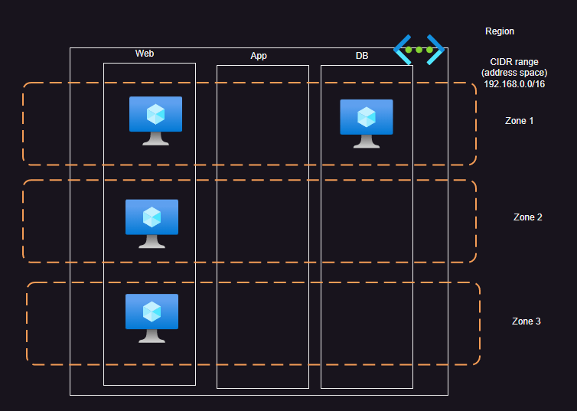

**Azure Resource Model**

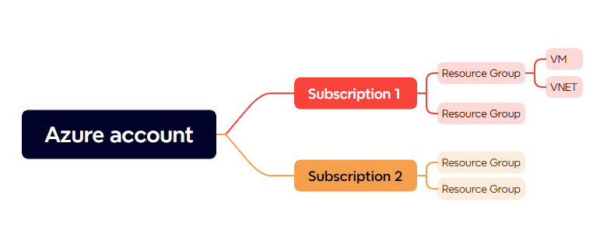

**Lets create a virtual network with 3 subnets in Azure**

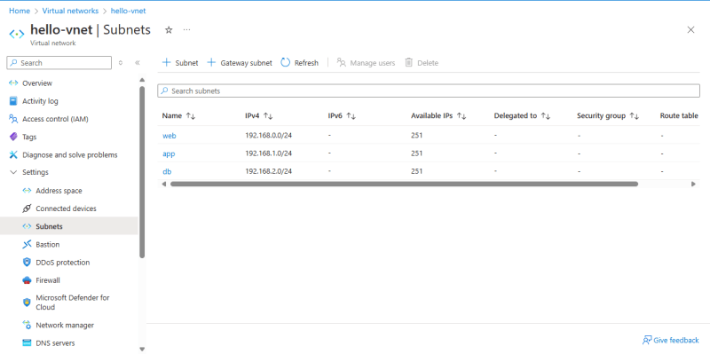

Azure supports one network security group which supports allow and deny rules that can be applied at two layer

* network interface (vm)
* subnet  
  